EPC User’s Guide

Editor: | EURECOM
Deliverable nature: | Public
Due date: | July, 2015
Delivery date: | June, 2015
Version: | 0.2
Total number of pages: | 32
Reviewed by:
Keywords: | EPC, LTE, MME, S-GW, HSS, S1AP, DIAMETER

Abstract
The deliverable presents the EPC developed by EURECOM.
The document presents the deployment scenarios of the EPC, its configuration, installation and running.

List of authors

Company | Authors
EURECOM | Christian BONNET, Lionel GAUTHIER, Rohit GUPTA, Florian KALTENBERGER, Raymond KNOPP, Navid NIKAIEN, Cedric ROUX.
 | Laurent THOMAS.

History
Modified by | Date | Version | Comments
Lionel GAUTHIER | 09/06/2015 | 0.1 | Initial Draft
Lionel GAUTHIER | 11/06/2015 | 0.2 | Minor corrections

Table of Contents
History 3
Table of Contents 4
List of Figures 6
List of tables 7
Abbreviations 8
1 Introduction 9
1.1 Overview 9
1.2 Deployment scenarios 9
1.2.1 Separate EPC platform 9
1.2.2 All in one EPC platform 10
2 EPC Installation 11
2.1 Operating system 11
2.2 EPC source code 11
2.3 Additional software, initial steps. 11
2.3.1 Mysql server installation details 12
2.3.2 Phpmyadmin installation details 12
3 EPC Configuration 14
3.1 MME_GW 14
3.1.1 Fully Qualified Domain name 14
3.1.2 Configuration files 14
3.2 MME 15
3.3 SP_GW 15
3.4 MME configuration content 15
3.4.1 GUMMEI section 15
3.4.2 SCTP section 16
3.4.3 S1AP section 16
3.4.4 S6A section 16
3.4.5 NAS section 16
3.4.6 INTERTASK_INTERFACE section 16
3.4.7 Network interfaces section 16
3.5 S-GW configuration content 17
3.6 P-GW configuration content 18
3.6.1 Main section 18
3.6.2 Network interfaces section 18
3.6.3 IP Address Pool section 18
3.7 HSS 19
3.7.1 Fully Qualified Domain name 19
3.7.2 Configuration files 19
3.7.3 HSS database content 22
4 Building and running 25
4.1 MME_GW. 25
4.1.1 Configuration files 25
4.1.2 Building EPC 25
4.1.3 Running EPC 25
5 Supported scenarios in EPC 27
5.1 E-UTRAN Initial attach 27
5.1.1 Attach with IMSI 27
5.1.2 Attach with GUTI 27
5.2 Tracking Area Update procedures 27
5.3 Routing Area Update procedures 27
5.4 Service Request procedures 27
5.4.1 UE triggered Service Request 27
5.4.2 Network triggered Service Request 27
5.5 S1 Release procedure 27
5.6 GUTI Reallocation procedure 27
5.7 Detach procedure 27
5.7.1 UE-Initiated Detach procedure for E-UTRAN 27
5.7.2 MME-Initiated Detach procedure for E-UTRAN 27
5.7.3 HSS-Initiated Detach procedure for E-UTRAN 27
5.8 HSS User Profile management function procedure 27
5.9 Bearer deactivation 27
5.9.1 PDN GW initiated bearer deactivation 27
5.9.2 MME initiated Dedicated Bearer Deactivation 27
5.10 Intra E-UTRAN handover 28
6 Annex A: Tools for observing, debugging. 29
6.1 Itti_analyzer 29
6.1.1 Installation 29
6.1.2 Execution 29
6.2 Wireshark/tshark 30
6.3 Mscgen 30
6.4 S1AP scenario replay 31
6.4.1 Capture a scenario 31
6.4.2 build a S1AP scenario from pcap trace 32
6.4.3 Replay a S1AP scenario 32

List of Figures
Figure 1 EPC overview 9
Figure 2 EPC Deployment in MME SP-GW 9
Figure 3 EPC Deployment in MME_GW 10
Figure 4 Mysql installation root password 12
Figure 5 Phpmyadmin installation conf DB 12
Figure 6 Phpmyadmin installation DB password 13
Figure 7 Phpmyadmin installation app password 13
Figure 8 Phpmyadmin installation web server selection 13
Figure 9 MME_GW configuration files generation 14
Figure 10 HSS configuration files generation 19
Figure 11 ITTI Analyzer main window 29
Figure 12 ITTI Analizer select filter menu 30
Figure 13 Mscgen output example 31

List of tables
Table 1 MME configuration main section 15
Table 2 MME configuration subsection GUMMEI 15
Table 3 MME configuration subsection SCTP 16
Table 4 MME configuration subsection S1AP 16
Table 5 MME configuration subsection S6a 16
Table 6 MME configuration subsection NAS 16
Table 7 MME configuration subsection ITTI 16
Table 8 MME configuration subsection Network Interfaces 17
Table 9 S-GW configuration main section 17
Table 10 P-GW configuration main section 18
Table 11 P-GW configuration subsection Network Interfaces 18
Table 12 P-GW configuration subsection IP Address Pool Selection 18
Table 13 SQL Table structure mmeidentity 22
Table 14 SQL Table structure pdn 23
Table 15 SQL Table structure users 24

Abbreviations
3GPP Third Generation Partnership Project.
APN Access Point Name.
CIDR Classless Inter-Domain Routing.
eNB e Node B.
EPC Evolved Packet Core.
EPS Evolved Packet System.
FQDN Fully qualified domain name.
HSS Home Subscriber Server.
IMEI International Mobile Station Equipment Identity.
IMEISV International Mobile Station Equipment Identity Software
Version.
LTE Long Term Evolution.
MME Mobility Management Entity.
MSISDN Mobile Station International Subscriber Directory Number.
NW Network.
P-GW PDN Gateway, Packet Data Network Gateway.
PDN Packet Data Network.
QoS Quality of Service.
SCTP Stream Control Transmission Protocol.
S-GW Serving Gateway.
SIM Subscriber Identity Module.
TCP Transmission Control Protocol.
USIM Universal Subscriber Identity Module.
- Introduction
  - Overview
The EURECOM EPC is a bundle of software components that provides the MME, S+P-GW, HSS functions of the LTE core EPC architecture (http://www.3gpp.org/DynaReport/23002.htm).
Actually the SGW and the PGW are merged together, there is no S5 or S8 interface between the two functional entities.

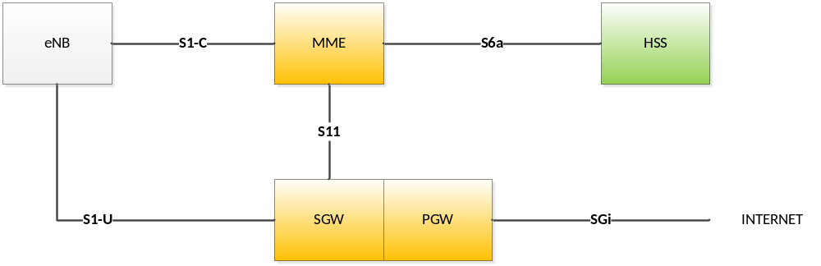
Figure 1 EPC overview

  - Deployment scenarios
Two deployment scenarios are considered with the EURECOM EPC.

    - Separate EPC platform
Actually this deployment scenario is under development and cannot be demonstrated yet.

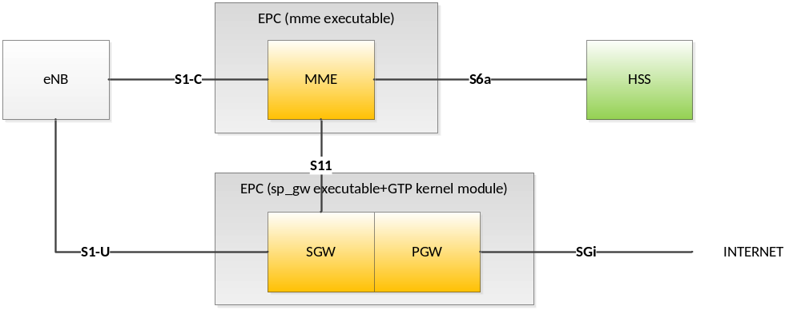
Figure 2 EPC Deployment in MME SP-GW

    - All in one EPC platform
The following picture depicts a EURECOM EPC providing MME and GW functions, and interact with the EURECOM HSS. In this deployment scenario, the S11 interface is virtual in the sense that S11 messages do not go through the network layer but through an inter-task interface message passing middleware (ITTI).

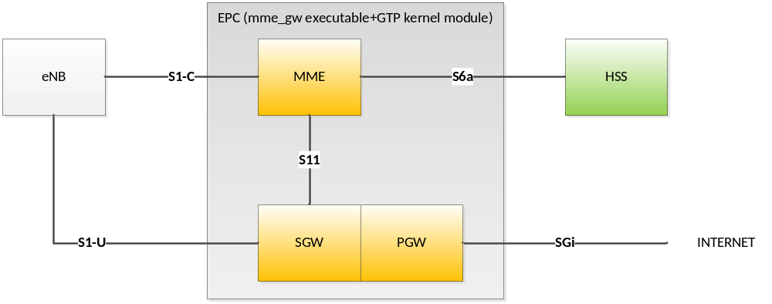
Figure 3 EPC Deployment in MME_GW

The EPC can be deployed on the same EURECOM eNB host or on its own host.
The HSS can be deployed on the same EPC host, EURECOM eNB host or on its own host. Any combination of deployment with one, two or three host(s) is possible with the EURECOM eNB.
If a third party eNB is used, then it is preferable to run the EPC and HSS on one or two other hosts, indifferently.

- EPC Installation
  - Operating system
The EPC software has only been tested on UBUNTU 14.04x64, and UBUNTU 14.10x64 LINUX distributions on Intel x86 64 bits platforms.
If you want to try another LINUX distribution, it is mandatory to have a 64 bits LINUX distribution.

  - EPC source code
The OpenAirInterface software can be obtained from our svn server. You will need an svn client to get the sources (on Ubuntu Linux the client can be install using the command "apt-get install subversion"). The openair4G repository is currently used for main developments. It can be accessed in read-only mode from the URL http://svn.eurecom.fr/openair4G. If you have full access to our SVN you should use the URL http://svn.eurecom.fr/openairsvn/openair4G.

Depending on what is recommended on the openair mailing list (openair4g-devel@eurecom.fr), you should use the trunk or the latest release.

If svn is not installed on your computer, execute in a shell the following command:
user@host:~ sudo apt-get install subversion

Then to retrieve the source code, if you have read-only access, execute in a shell the following command:
user@host:~ svn co http://svn.eurecom.fr/openair4G/trunk
or
user@host:~ svn co http://svn.eurecom.fr/openair4G/releases/rel_x.y_dd.mm.yyyy
If you have write access:
user@host:~ svn co http://svn.eurecom.fr/openairsvn/openair4G --username mysvnlogin

The source code in a release directory or in the trunk directory is organized as follow:
- cmake_targets : Openair build system (latest)
- common : Common code to all layers
- openair1 : Physical layer source code
- openair2 : Layer 2(MAC, RLC, RRC, PDCP) source code
- openair3 : Middleware code (mainly unused).
- openair-cn : Core network protocols source code.
- targets : Specific code for executables (may contains unsupported old build system).

Important!
In this document OPENAIR_DIR is the path to the openair working directory (may be trunk or rel_x.y_dd.mm.yyyy).

  - Additional software, initial steps.
Some software installations have to be done prior to build the EURECOM EPC and the EURECOM HSS.
In OPENAIR_DIR/cmake_targets directory, execute the following command:
user@host:~/openair4G/trunk/cmake_targets$ tools/build_epc –i

This command will update the software source list of your Ubuntu installation. It will install miscellaneous software packages, mainly an openair version (patched) of freeDiameter, an openair version (patched) of asn1c, and particularly mysql-server and phpmyadmin software, which steps are described below.

    - Mysql server installation details
Enter here the root password of your host.
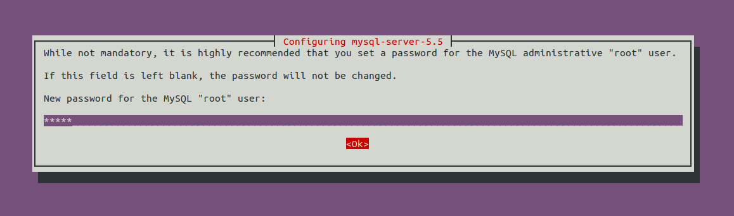
Figure 4 Mysql installation root password

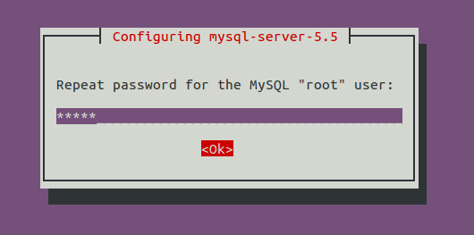
The mysql-server installation process ends here.
    - Phpmyadmin installation details
You should prefer the easiest way
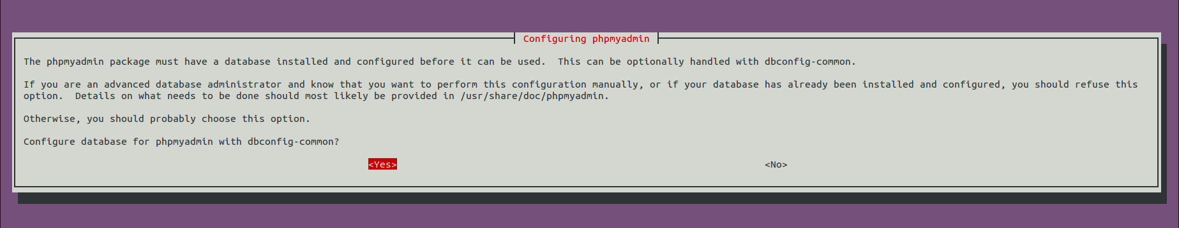
Figure 5 Phpmyadmin installation conf DB

Enter here the root password of your host:
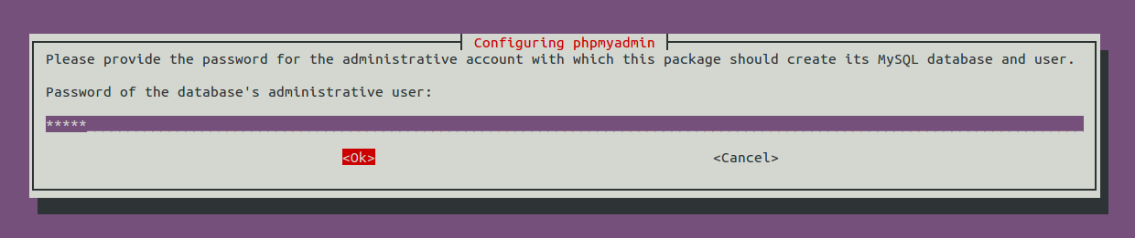
Figure 6 Phpmyadmin installation DB password

Accordingly with the content of openair configuration files, please, enter here admin
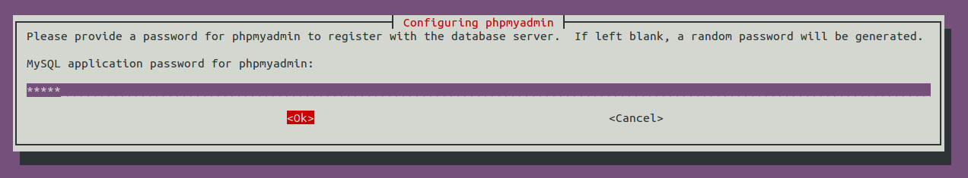
Figure 7 Phpmyadmin installation app password

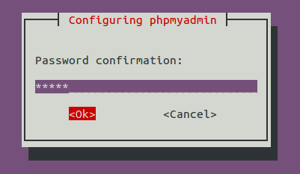

Choose the web server that has to be configured: Apache.
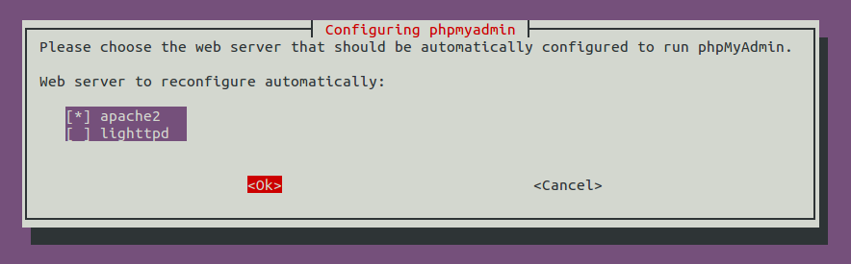
Figure 8 Phpmyadmin installation web server selection

- EPC Configuration

  - MME_GW
    - Fully Qualified Domain name
A FQDN has to be set for the MME_GW. An easy way to do that is to fill this FQDN in the /etc/hosts file.
Example:
yang@yang:$ cat /etc/hosts
127.0.0.1 localhost
127.0.1.1 yang.openair4G.eur yang
...
192.168.12.175 yin.openair4G.eur hss yin
...
    - Configuration files
Here is view of the build process of MME_GW, we can see there when and how configuration files are generated. Inputs files and parameters are on the left part of the figure, the build process is in the center part and output configuration files are on the right of the figure.

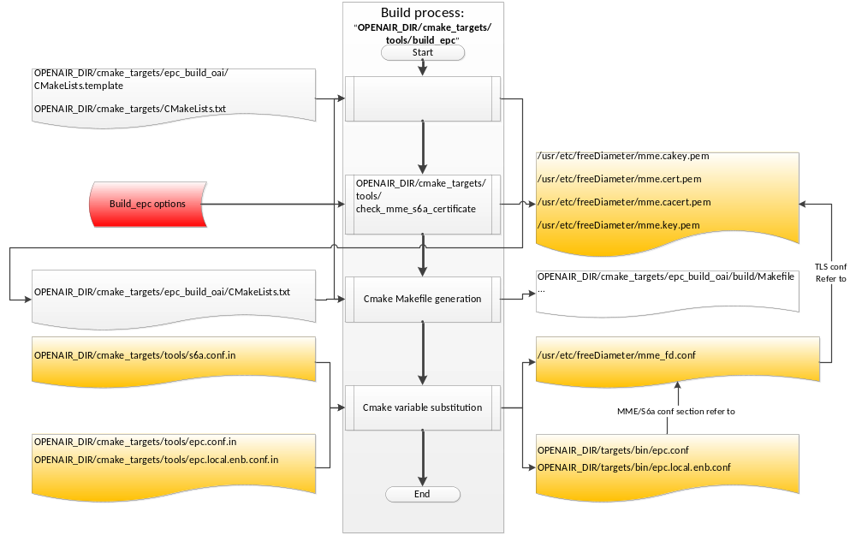
Figure 9 MME_GW configuration files generation

Configuration file Epc.conf and epc.local.enb.conf:
These configuration files, since MME_GW is an aggregation of a MME, a S-GW and a P-GW, aggregate three configuration sections: a MME, a S-GW, and a P-GW configuration section.
This configuration files follow the libconfig file syntax (http://www.hyperrealm.com/libconfig).
These sections are described below.

Configuration file mme_fd.conf:
This configuration file is the input file for configuring the diameter protocol instance of the MME_GW.

  - MME
Empty section, will be updated when a standalone MME will be released.

  - SP_GW
Empty section, , will be updated when a standalone S+P-GW will be released.

  - MME configuration content
Parameter | Type
REALM | String | Diameter realm of the MME
MAXENB | Num/Integer | Maximum number of eNB that can connect to MME.
MAXUE | Num/Integer | For debug purpose, used to restrict the number of served UEs the MME can handle.
RELATIVE_CAPACITY | Num/Integer | Even though this parameter is not used by the MME for controlling the MME load balancing within a pool (at least for now), the parameter has to be forwarded to the eNB during association procedure. Values going from 0 to 255, (Default value is 15)
MME_STATISTIC_TIMER | Num/Integer | Displayed statistic (stdout) period.
EMERGENCY_ATTACH_SUPPORTED | String
UNAUTHENTICATED_IMSI_SUPPORTED | String
IP_CAPABILITY | String | Choice between IPV4, IPV4V6, IPV4ORV6
Table 1 MME configuration main section

    - GUMMEI section

Parameter | Type
MME_CODE | Array of Num/Integer | List of a maximum of 256 values can be provided. MME code range is [0..255]
MME_GID | Array of Num/Integer | List of maximum 65536 values. MME group id range is [0..65535]
TAI | Array of TAI (PLMN:TAC) | List of maximum 32 TAI. (TAI=MCC.MNC:TAC)
Table 2 MME configuration subsection GUMMEI

    - SCTP section
Parameter | Type
SCTP_INSTREAMS | Num/Integer | Num streams for UE association signaling, note that stream with id =0 is reserved for non-Ue associated signaling. At least two streams should be used by the MME. (Default value=64)
SCTP_OUTSTREAMS | Num/Integer | Idem above
Table 3 MME configuration subsection SCTP

    - S1AP section
Parameter | Type
S1AP_OUTCOME_TIMER | Num/Integer | Once an outcome is sent from MME to eNB, the MME locally starts a timer to abort the procedure and release UE context if the expected answer to this outcome is not received at the expiry of this timer. This timer is expressed in seconds. (Default value = 5 seconds)
Table 4 MME configuration subsection S1AP

    - S6A section
Parameter | Type
S6A_CONF | String | S6A config file path
HSS_HOSTNAME | String | HSS hostname
Table 5 MME configuration subsection S6a

    - NAS section
Parameter | Type
ORDERED_SUPPORTED_INTEGRITY_ALGORITHM_LIST | Array of String | Preference list in decreasing order of supported integrity algorithms, actually supported integrity algorithms are EIA0, EIA1, EIA2
ORDERED_SUPPORTED_CIPHERING_ALGORITHM_LIST | Array of String | Preference list in decreasing order of supported integrity algorithms, actually supported integrity algorithms are EEA0, EEA1, EEA2
Table 6 MME configuration subsection NAS

    - INTERTASK_INTERFACE section
Parameter | Type
ITTI_QUEUE_SIZE | Num/Integer | Upper bound for the message queue size expressed in bytes (all messages exchanged by tasks have the same size). Restrict the number of messages in queues or detect a possible MME overload.
Table 7 MME configuration subsection ITTI

    - Network interfaces section
Parameter | Type
MME_INTERFACE_NAME_FOR_S1_MME | String | Interface name for S1-MME (S1-C)
MME_IPV4_ADDRESS_FOR_S1_MME | String, CIDR | Binded address for S1-MME
MME_INTERFACE_NAME_FOR_S11_MME | String | Interface name for S11, “none” if S11 unused
MME_IPV4_ADDRESS_FOR_S11_MME | String, CIDR | Binded address for S11, (0.0.0.0/xx) if S11 unused
Table 8 MME configuration subsection Network Interfaces

  - S-GW configuration content
Parameter | Type
SGW_INTERFACE_NAME_FOR_S11 | String | Interface name for S11, “none” if S11 unused
SGW_IPV4_ADDRESS_FOR_S11 | String, CIDR notation | Binded address for S11, (0.0.0.0/xx) if S11 unused
SGW_INTERFACE_NAME_FOR_S1U_S12_S4_UP | String | Interface name for S1-U
SGW_IPV4_ADDRESS_FOR_S1U_S12_S4_UP | String, CIDR notation | Binded address for S1-U
SGW_IPV4_PORT_FOR_S1U_S12_S4_UP | Num/Integer | Port number for S1-U (IANA), Should be 2152
SGW_INTERFACE_NAME_FOR_S5_S8_UP | String, | Interface name for S5 or S8, “none” because unused
SGW_IPV4_ADDRESS_FOR_S5_S8_UP | String, CIDR notation | Binded address for S5 or S8, (0.0.0.0/xx) because unused
Table 9 S-GW configuration main section

  - P-GW configuration content
    - Main section
Parameter | Type
DEFAULT_DNS_1_IPV4_ADDRESS | String, IPv4 dot decimal | IPv4 address of primary default DNS that can be queried by UEs
DEFAULT_DNS_2_IPV4_ADDRESS | String, IPv4 dot decimal | IPv4 address of secondary default DNS that can be queried by UEs
Table 10 P-GW configuration main section

    - Network interfaces section
Parameter | Type
PGW_INTERFACE_NAME_FOR_S5_S8 | String | Interface name for S5 or S8, “none” because unused
PGW_IPV4_ADDRESS_FOR_S5_S8 | String, CIDR notation | Binded address for S5 or S8, (0.0.0.0/xx) because unused
PGW_INTERFACE_NAME_FOR_SGI | String | Interface name for SGi
PGW_IPV4_ADDRESS_FOR_SGI | String, CIDR notation | Used IPv4 address for SGi, useful if UE traffic is masqueraded.
PGW_MASQUERADE_SGI | String | Should outgoing UE IPv4 traffic be masqueraded (source NAT), “yes” or “no”.
Table 11 P-GW configuration subsection Network Interfaces

    - IP Address Pool section
Parameter | Type
IPV4_LIST | String, CIDR notation | List of IPv4 netmasks that designate a list of available IPv4 addresses for UEs
IPV6_LIST | String, CIDR notation | List of IPv6 netmasks that designate a list of available IPv6 addresses for UEs
Table 12 P-GW configuration subsection IP Address Pool Selection

  - HSS
    - Fully Qualified Domain name
A FQDN has to be set for the HSS. An easy way to do that is to fill this FQDN in the /etc/hosts file.
Example:
yin@yin:$ cat /etc/hosts
127.0.0.1 localhost
127.0.1.1 yin.openair4G.eur yin
...
    - Configuration files
Here is partial view of the build process of HSS, we can see there when and how configuration files are generated. Inputs files and parameters are on the left part of the figure, the build process is in the center part and output configuration files are on the right of the figure.

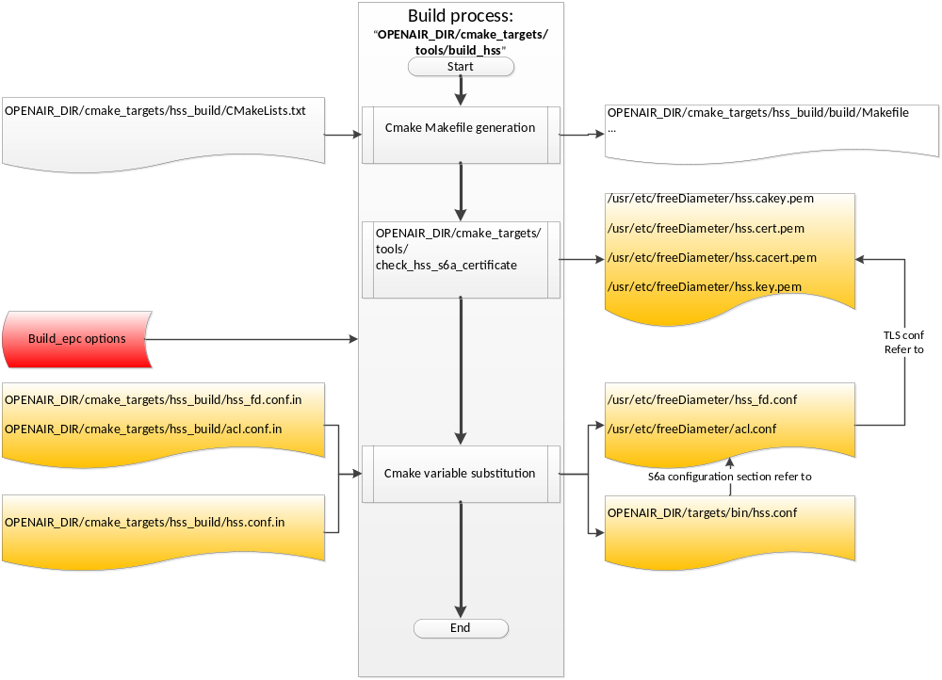
Figure 10 HSS configuration files generation
Configuration file hss.conf.in:
This configuration file is the top configuration file containing all necessary parameters and links to other configuration files. This file do not need to be edited, all parameters passed to the build_hss executable and also its default parameters are substituted in the right place in this config file.
hss.conf.in content:
## MySQL mandatory options
MYSQL_server = "@MYSQL_server@";
MYSQL_user = "@MYSQL_user@";
MYSQL_pass = "@MYSQL_pass@";
MYSQL_db = "@MYSQL_db@";

## HSS options
OPERATOR_key = "@OPERATOR_key@";

RANDOM = "@RANDOM_boolean@";

## Freediameter options
FD_conf = "@FREEDIAMETER_PATH@/../etc/freeDiameter/hss_fd.conf";

The following is an example of the resulting config file hss.conf:
## MySQL mandatory options
MYSQL_server = "127.0.0.1";
MYSQL_user = "hssadmin";
MYSQL_pass = "admin";
MYSQL_db = "oai_db";

## HSS options
OPERATOR_key = "11111111111111111111111111111111";

RANDOM = "FALSE";

## Freediameter options
FD_conf = "/usr/lib/../etc/freeDiameter/hss_fd.conf";

Configuration file hss_fd.conf.in:
This configuration file is the input file for configuring the diameter protocol instance of the HSS.
All parameters values between ‘@’ are filled by the cmake process. These parameters are set with the help of input parameters passed to the build_hss executable, and with the help of default values set in the cmake_targets/hss_build/CMakeLists.txt file.
You can see here what are default values defined in cmake_targets/hss_build/CMakeLists.txt and set your own:
set(MYSQL_server "127.0.0.1" CACHE STRING "Database server IP address")
set(MYSQL_admin root CACHE STRING "Database admin login")
set(MYSQL_admin_pass linux CACHE STRING "Database admin password")
set(MYSQL_user hssadmin CACHE STRING "Database username login")
set(MYSQL_pass admin CACHE STRING "Database username password")
set(MYSQL_db oai_db CACHE STRING "Database name")
set(TRANSPORT_option "#No_TCP" CACHE STRING "No_TCP or No_SCTP or comment string, FreeDiameter config option")
set(TRANSPORT_PREFER_TCP_option "#Prefer_TCP" CACHE STRING "Prefer_TCP or comment string, FreeDiameter config option")
set(AppServThreads 2 CACHE STRING "FreeDiameter AppServThreads config option")
set(OPERATOR_key "" CACHE STRING "LTE operator clear text key (hex bytes) example 11111111111111111111111111111111")
set(RANDOM_boolean "true" CACHE STRING "If false, random function returns always 0, else random as usual.")
set(REMOTE_PEER_WHITELIST "*.${REALM}" CACHE STRING "Remote peer whitelist (separated by spaces), for freediameter acl.conf config file")

hss_fd.conf.in content:
# -------- Local ---------
# The first parameter in this section is Identity, which will be used to
# identify this peer in the Diameter network. The Diameter protocol mandates
# that the Identity used is a valid FQDN for the peer. This parameter can be
# omitted, in that case the framework will attempt to use system default value
# (as returned by hostname --fqdn).
Identity = "@HSS_FQDN@";

# In Diameter, all peers also belong to a Realm. If the realm is not specified,
# the framework uses the part of the Identity after the first dot.
Realm = "@REALM@";

# This parameter is mandatory, even if it is possible to disable TLS for peers
# connections. A valid certificate for this Diameter Identity is expected.
TLS_Cred = "@FREEDIAMETER_PATH@/../etc/freeDiameter/hss.cert.pem", "@FREEDIAMETER_PATH@/../etc/freeDiameter/hss.key.pem";
TLS_CA = "@FREEDIAMETER_PATH@/../etc/freeDiameter/hss.cacert.pem";

# Disable use of TCP protocol (only listen and connect in SCTP)
# Default : TCP enabled
@TRANSPORT_option@;

# This option is ignored if freeDiameter is compiled with DISABLE_SCTP option.
# Prefer TCP instead of SCTP for establishing new connections.
# This setting may be overwritten per peer in peer configuration blocs.
# Default : SCTP is attempted first.
@TRANSPORT_PREFER_TCP_option@;

# Disable use of IPv6 addresses (only IP)
# Default : IPv6 enabled
No_IPv6;

# Overwrite the number of SCTP streams. This value should be kept low,
# especially if you are using TLS over SCTP, because it consumes a lot of
# resources in that case. See tickets 19 and 27 for some additional details on
# this.
# Limit the number of SCTP streams
SCTP_streams = 3;

# By default, freeDiameter acts as a Diameter Relay Agent by forwarding all
# messages it cannot handle locally. This parameter disables this behavior.
NoRelay;

TLS_old_method;

# Number of parallel threads that will handle incoming application messages.
# This parameter may be deprecated later in favor of a dynamic number of threads
# depending on the load.
AppServThreads = @AppServThreads@;

# Specify the addresses on which to bind the listening server. This must be
# specified if the framework is unable to auto-detect these addresses, or if the
# auto-detected values are incorrect. Note that the list of addresses is sent
# in CER or CEA message, so one should pay attention to this parameter if some
# adresses should be kept hidden.
@ListenOn@;

@DIAMETER_PORT@;
@DIAMETER_SEC_PORT@;

# -------- Extensions ---------

# Uncomment (and create rtd.conf) to specify routing table for this peer.
#LoadExtension = "rt_default.fdx" : "rtd.conf";

# Uncomment (and create acl.conf) to allow incoming connections from other peers.
LoadExtension = "acl_wl.fdx" : "@FREEDIAMETER_PATH@/../etc/freeDiameter/acl.conf";

# Uncomment to display periodic state information
#LoadExtension = "dbg_monitor.fdx";

# Uncomment to enable an interactive Python interpreter session.
# (see doc/dbg_interactive.py.sample for more information)
#LoadExtension = "dbg_interactive.fdx";

# Load the RFC4005 dictionary objects
#LoadExtension = "dict_nasreq.fdx";

LoadExtension = "dict_nas_mipv6.fdx";
LoadExtension = "dict_s6a.fdx";

# Load RFC4072 dictionary objects
#LoadExtension = "dict_eap.fdx";

# Load the Diameter EAP server extension (requires diameap.conf)
#LoadExtension = "app_diameap.fdx" : "diameap.conf";

# Load the Accounting Server extension (requires app_acct.conf)
#LoadExtension = "app_acct.fdx" : "app_acct.conf";

# -------- Peers ---------

# The framework will actively attempt to establish and maintain a connection
# with the peers listed here.
# For only accepting incoming connections, see the acl_wl.fx extension.

#ConnectPeer = "ubuntu.localdomain" { ConnectTo = "127.0.0.1"; No_TLS; };
@ConnectPeer@ = "@MME_FQDN@" { ConnectTo = "@MME_IP@"; Realm = "@REALM@"; No_IPv6; No_TLS ; port = 3870; };

Configuration file acl.conf.in:
TODO

    - HSS database content
SQL operations (display, update, export, etc) can be done easily with the help of phpMyAdmin, you have to open the following URL with your browser: http://yourhsshost/phpmyadmin.
Otherwise you can use any other MySQL tool, script compatible with MySQL.

Table mmeidentity:
Structure:
Field | Type | Null | Key | Default | Extra
idmmeidentity | int(11) | NO | PRI | NULL | auto_increment
mmehost | varchar(255) | YES |  | NULL
mmerealm | varchar(200) | YES |  | NULL
UE-Reachability | tinyint(1) | NO |  | NULL
Table 13 SQL Table structure mmeidentity
Column idmmeIdentity is the primary key of a MME.
Column mmehost contains the FQDN of a MME.
Column mmerealm contains the realm of a MME.

Example of content:
+---------------+------------------------+---------------+-----------------+
| idmmeidentity | mmehost | mmerealm | UE-Reachability |
+---------------+------------------------+---------------+-----------------+
| 2 | yang.openair4G.eur | openair4G.eur | 0 |
| 1 | ng40-erc.openair4G.eur | openair4G.eur | 0 |
| 3 | ABEILLE.openair4G.eur | openair4G.eur | 0 |
+---------------+------------------------+---------------+-----------------+

Table pdn:
This table contains mainly the association between a user and a APN, and its QOS parameters.

Structure:
Field | Type | Null | Key | Default | Extra
id | int(11) | NO | PRI | NULL | auto_increment
apn | varchar(60) | NO |  | NULL
pdn_type | enum('IPv4','IPv6','IPv4v6','IPv4_or_IPv6') | NO |  | NULL
pdn_ipv4 | varchar(15) | YES |  | NULL | 0.0.0.0
pdn_ipv6 | varchar(45) | YES |  | NULL | 0:0:0:0:0:0:0:0
aggregate_ambr_ul | int(10) unsigned | YES |  | 50000000
aggregate_ambr_dl | int(10) unsigned | YES |  | 100000000
pgw_id | int(11) | NO | PRI | NULL
users_imsi | varchar(15) | NO | PRI
qci | tinyint(3) unsigned | NO |  | 9
priority_level | tinyint(3) unsigned | NO |  | 15
pre_emp_cap | enum('ENABLED','DISABLED') | YES |  | DISABLED
pre_emp_vul | enum('ENABLED','DISABLED') | YES |  | DISABLED
LIPA-Permissions | enum('LIPA-prohibited','LIPA-only','LIPA-conditional') | YES |  | LIPA-only
Table 14 SQL Table structure pdn
Column id is the primary key of a pdn entry.
Column pdn_type contains the type of PDN, actually only IPv4 is supported.
Column pdn_ipv4 contains the IPv4 address of the PDN (unused).
Column pdn_ipv6 contains the IPv6 address of the PDN (unused).
Column aggregate_ambr_ul TODO
Column aggregate_ambr_dl TODO
Column pgw_id TODO
Column users_imsi TODO
Column qci TODO
Column priority_level TODO
Column pre_emp_capability TODO
Column pre_emp_vulnerability TODO
Column LIPA_Permissions TODO

Table users
Structure:

Field | Type | Null | Key | Default | Extra
imsi | varchar(15) | NO | PRI | NULL
msisdn | varchar(46) | YES |  | NULL
imei | varchar(15) | YES |  | NULL
imei_sv | varchar(2) | YES |  | NULL
ms_ps_status | enum('PURGED','NOT_PURGED') | YES |  | PURGED
rau_tau_timer | int(10) unsigned | YES |  | 120
ue_ambr_ul | bigint(20) unsigned | YES |  | 50000000
ue_ambr_dl | bigint(20) unsigned | YES |  | 100000000
access_restriction | int(10) unsigned | YES |  | 60
mme_cap | int(10) unsigned zerofill | YES |  | NULL
mmeidentity_idmmeidentity | int(11) | NO | PRI | 0
key | varbinary(16) | NO |  | 0
RFSP-Index | smallint(5) unsigned | NO |  | 1
urrp_mme | tinyint(1) | NO |  | 0
sqn | bigint(20) unsigned zerofill | NO |  | NULL
rand | varbinary(16) | NO |  | NULL
OPc | varbinary(16) | YES |  | NULL
Table 15 SQL Table structure users
TODO column description.

- Building and running

The EURECOM EPC interact mainly with two other entities: the eNB and the HSS. Depending on the location of these entities on the same host or not, the building and running options differ:
- When EPC and HSS run on the same host, TCP must be selected as the underlying protocol for DIAMETER on the S6a interface. If EPC and HSS run on separate hosts, SCTP can be selected as the underlying protocol for DIAMETER on the S6a interface. Choosing SCTP instead of TCP makes the network capture of S1-MME traffic easier.
- Depending if EPC and EURECOM eNB run on the same host or not, for convenience, two different configuration files are provided, one for each situation.
We recommend to follow the step described below, unless you know what you are doing.

  - MME_GW.
Your EURECOM MME_GW host and your EURECOM HSS host (may be the same host)
    - Configuration files
Configuration files have to be filled prior to compilation.
If the MME_GW and the eNB run on the same host, fill OPENAIR_DIR/cmake_targets/tools/epc.local.enb.conf.in configuration file, else fill OPENAIR_DIR/cmake_targets/tools/epc.conf.in configuration file.

    - Building EPC
In a shell go to your openair root directory (openair4G/trunk or openair4G/releases/rel_xxxxx):
If MME_GW and the HSS run on the same host, execute the following commands:
user@host:~/openair4G/trunk/cmake_targets$ tools/build_epc --debug --s6a-server --transport-tcp-only --transport-prefer-tcp (optional parameter --clean)
user@host:~/openair4G/trunk/cmake_targets$ tools/build_hss --debug –-connect-to-mme yourmmefqdn --transport-tcp-only --transport-prefer-tcp (optional parameters: --clean –-operator-key 11111111111111111111111111111111 for example)

Else, execute the following command:
- On MME_GW host:
user@host:~/openair4G/trunk/cmake_targets$ tools/build_epc --debug --hss yourhssfqdn --transport-sctp-only (optional parameter --clean)
- On HSS host:
user@host:~/openair4G/trunk/cmake_targets$ tools/build_hss --debug --transport-sctp-only (optional parameters: --clean –-operator-key 11111111111111111111111111111111 for example)

    - Running EPC
In a shell go to your openair root directory (openair4G/trunk or openair4G/releases/rel_xxxxx):
If MME_GW and the HSS run on the same host, execute the following commands:
user@host:~/openair4G/trunk/cmake_targets$ tools/run_epc –l
user@host:~/openair4G/trunk/cmake_targets$ tools/run_hss

Else, execute the following command:
- On HSS host:
user@host:~/openair4G/trunk/cmake_targets$ tools/run_hss
- On MME_GW host:
user@host:~/openair4G/trunk/cmake_targets$ tools/run_epc

Have a look at all these executables options (-h option)

- Supported scenarios in EPC
  - E-UTRAN Initial attach
    - Attach with IMSI
TBD
    - Attach with GUTI
TBD
  - Tracking Area Update procedures
TBD
  - Routing Area Update procedures
Not supported yet.
  - Service Request procedures
    - UE triggered Service Request
TBD
    - Network triggered Service Request
Not supported yet.
  - S1 Release procedure
TBD
  - GUTI Reallocation procedure
  - Detach procedure
    - UE-Initiated Detach procedure for E-UTRAN
    - MME-Initiated Detach procedure for E-UTRAN
    - HSS-Initiated Detach procedure for E-UTRAN
Not supported.
  - HSS User Profile management function procedure
Not supported.
  - Bearer deactivation
    - PDN GW initiated bearer deactivation
Not supported
    - MME initiated Dedicated Bearer Deactivation
TBD
  - Intra E-UTRAN handover
Not supported yet

- Annex A: Tools for observing, debugging.

  - Itti_analyzer
Itti_analyzer takes a dump of messages exchanges between the executable (mme_gw or eNB, UE) tasks as input and display these messages in a human readable and comprehensible way. This tool can take as input a file whose content is the XML dump of ITTI messages exchanged between tasks or can act as a server and listen on a socket that a openair executable connects and dump messages in pseudo real-time. Trace messages are also displayed with the tool, but in a second view, that means not interlaced with ITTI messages.

Important:
Prior to use itti_analyzer, you have to instruct the openair executable to dump the ITTI messages to a file with the argument –K path_to_file.

    - Installation
In OPENAIR_DIR/common/utils/itti_analyzer directory, execute the following command:
user@host:~ autoreconf –i
user@host:~ ./configure
user@host:~ make
user@host:~ sudo make install
The itti_analyzer executable is now installed on the computer (/usr/local/bin)

    - Execution
In a shell, execute the following command:
user@host:~ itti_analyzer
The GUI displayed:

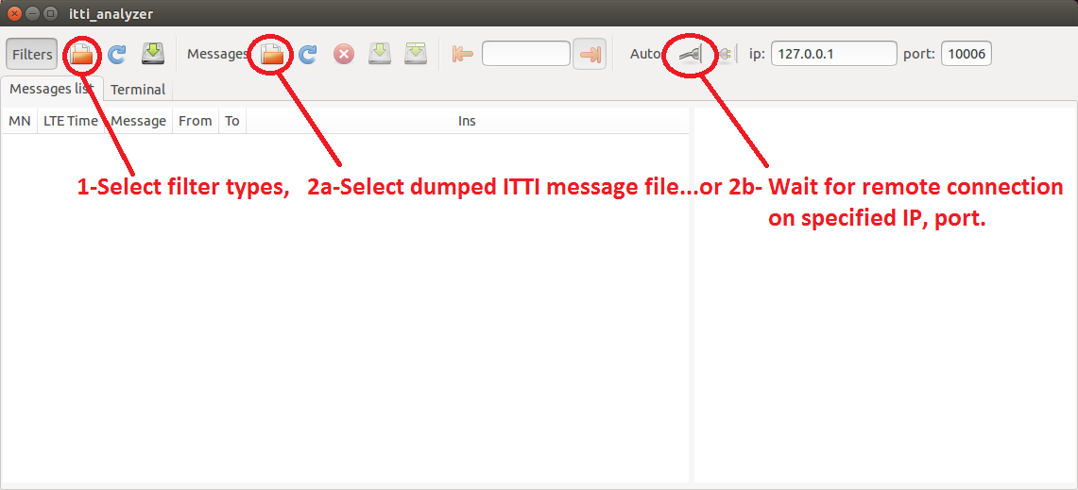
Figure 11 ITTI Analyzer main window

For filter selection, please use filters_mme.xml:

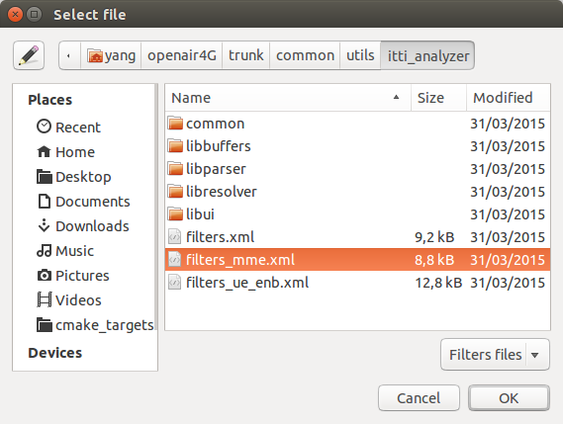
Figure 12 ITTI Analizer select filter menu

You can also use options for fastest operations:
user@host:~itti_analyzer -h
Usage: itti_analyser [options]
Options:
-d DISSECT write DISSECT file with message types parse details
-f FILTERS read filters from FILTERS file
-h display this help and exit
-i IP set ip address to IP
-l LEVEL set log level to LEVEL in the range of 2 to 7
-m MESSAGES read messages from MESSAGES file
-p PORT set port to PORT

  - Wireshark/tshark
You can launch wireshark instances on S1 (filter s1ap, gtpu), S6A (filter diameter, if TCP is the undelying protocol, you can select a TCP packet relative to the DIAMETER exchange and the select decode as DIAMETER).

  - Mscgen
Extract from http://www.mcternan.me.uk/mscgen/: “Mscgen is a small program that parses Message Sequence Chart descriptions and produces PNG, SVG, EPS or server side image maps (ismaps) as the output. Message Sequence Charts (MSCs) are a way of representing entities and interactions over some time period”…” Mscgen aims to provide a simple text language that is clear to create, edit and understand, which can also be transformed into common image formats for display or printing.”…

Openair use mscgen to offer another view of events (SDUs, timers, etc) that happens inside an executable and also (still under development) PDUs exchanged between protocol entities.
Openair HSS do not have the msgen feature.

Important:
Check that mscgen traces are configured for being generated (CFLAG MESSAGE_CHART_GENERATOR set to true in OPENAIR_DIR/cmake_targets/epc_build_oai/CMakeLists.template)
You have to instruct the openair mme_gw executable to dump the ITTI messages to a file with the argument -m path_to_directory. The mscgen files will be located under the specified directory, in a directory containing the time of the generated traces (text and png files).

Example:

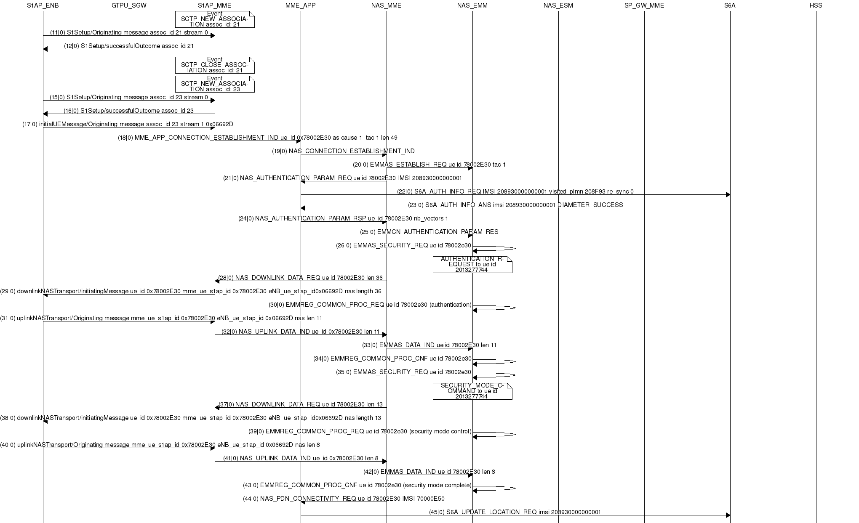
Figure 13 Mscgen output example

  - S1AP scenario replay
(Not released, under development)
The aim of this tool is for debug purpose when replaying a scenario is needed, it can also be used for non-regression tests.
This tool takes as input the pcap record of S1AP exchanges between eNB and MME, and also some records of the HSS database, then generate C code that replays the scenario.
To make this possible it is necessary to configure the HSS not to randomize the keys (build_hss [your options] --random no).
Steps:
    - Capture a scenario
- Configure your EPC environment.
- Start a pcap capture of s1ap protocol on S1 interface with wireshark or tshark.
- Capture a snapshot of the database with the tool xxxx
- Play the scenario with the EPC, eNB(s), UE(s).
- Save the pcap trace and the snapshot of the database.
    - build a S1AP scenario from pcap trace
TODO
    - Replay a S1AP scenario
TODO.

