E-UTRAN USER GUIDE

Editor: | EURECOM
Deliverable nature: | Public
Due date: | July, 2015
Delivery date: | July, 2015
Version: | 0.1
Total number of pages: | 25
Reviewed by:
Keywords: | LTE, eNB, UE, S1AP, GTP

List Of Authors

Company | Authors
Eurecom | Christian BONNET, Lionel GAUTHIER, Rohit GUPTA, Florian KALTENBERGER, Raymond KNOPP, Navid NIKAIEN, Cedric ROUX.

Revision History
The following table is a record of the main modifications done to the document since its creation.
Version | Author | Date | Description
1.0 | Navid Nikaein | 20/07/2015 | Initial Draft

Executive Summary
The deliverable presents the eNB, UE developed by EURECOM.
The document presents the deployment scenarios of the E-UTRAN, its configuration, installation and running.

Introduction
The EURECOM eNB is a bundle of software components that provides the eNB functions of the LTE on both radio interface (i.e. Uu ) and core network interfaces (i.e. S1-C and S1-U).

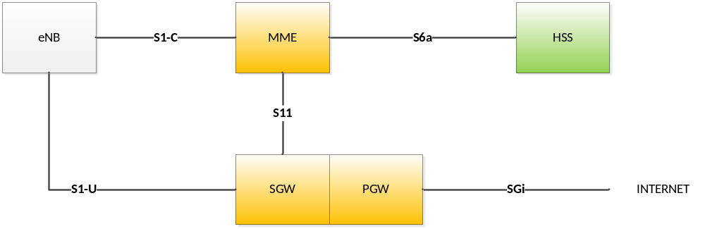
Figure 1 LTE overview

Deployment scenarios
Different deployment scenarios can be considered with the EURECOM eNB and UE as follows [1]:
- Commercial UE <-> OAI eNB + Commercial EPC
- Commercial UE <-> OAI eNB + OAI EPC
- Commercial UE <-> Commercial eNB + OAI EPC
- OAI UE <-> Commercial eNB + OAI EPC (experimental)
- OAI UE <-> Commercial eNB + Commercial EPC (experimental)
- OAI UE <-> OAI eNB + Commercial EPC (experimental)
- OAI UE <-> OAI eNB + OAI EPC
- OAI UE <-> OAI eNB
Below we present few of them.

eNB without S1 interface

In this deployment, S1AP and GTP protocols are bypassed, and thus eNB exchange the IP packets with the upper layer through the OAI network device driver called nasmesh.
To setup a radio link, you require OAI UE with the network device driver and without the NAS protocol.
One example scenario here is LTE-u.

ENB with S1 Interface
In this deployment, eNB is built with the S1AP and GTP protocols and interacts with EPC. Different EPC may be connected to the OAI eNB in addition to the OAI EPC.
Below, we provide few examples with OAI EPC.

eNB with all-in-one OAI EPC platform
The following picture depicts a EURECOM eNB and EPC providing MME and GW functions, and interact with the EURECOM HSS. In this deployment scenario, the S11 interface is virtual in the sense that S11 messages do not go through the network layer but through an inter-task interface message passing middleware (ITTI).
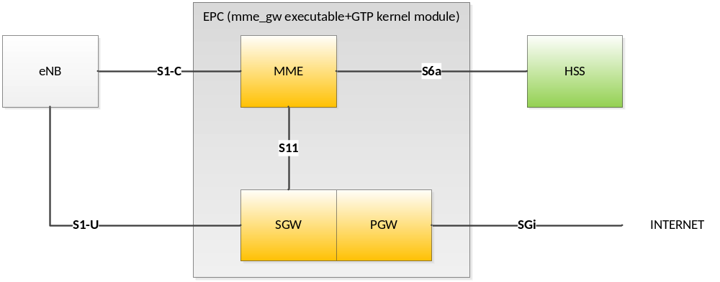
Figure 2 OAI eNB with all-in-one OAI EPC
The EPC can be deployed on the same host as OAI eNB host or on its own host.

eNB with separate EPC platform
Actually this deployment scenario is under development and cannot be demonstrated yet.
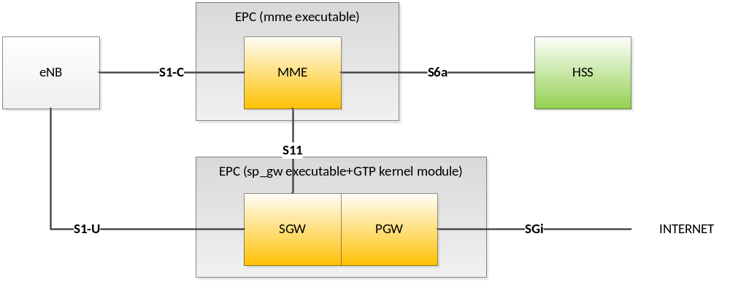

eNB on virtualized environments
TBC: See [2].

Containers (LXC and Dockers)

KVM

eNB Installation
The eNB and UE software have only been tested on UBUNTU 14.04x64, and UBUNTU 14.10x64 LINUX distributions on Intel x86 64 bits platforms, and to less extend on Debian.
In addition, low latency kernel is required. For kernel installation, please refer to [3].
If you want to try another LINUX distribution, it is mandatory to have a 64 bits LINUX distribution.

eNB source code

The OpenAirInterface software can be obtained from our svn server. You will need an svn client to get the sources (on Ubuntu Linux the client can be install using the command "apt-get install subversion"). The openair4G repository is currently used for main developments. It can be accessed in read-only mode from the URL http://svn.eurecom.fr/openair4G. If you have full access to our SVN you should use the URL http://svn.eurecom.fr/openairsvn/openair4G.
Depending on what is recommended on the openair mailing list (openair4g-devel@eurecom.fr), you should use the trunk or the latest release.
If svn is not installed on your computer, execute in a shell the following command:
user@host:~ sudo apt-get install subversion

Then to retrieve the source code, if you have read-only access, execute in a shell the following command:
user@host:~ svn co http://svn.eurecom.fr/openair4G/trunk
If you have write access:
user@host:~ svn co http://svn.eurecom.fr/openairsvn/openair4G --username mysvnlogin

The source code in a release directory or in the trunk directory is organized as follow:
- cmake_targets : Openair build system (latest)
- common : Common code to all layers
- openair1 : Physical layer source code
- openair2 : Layer 2(MAC, RLC, RRC, PDCP) source code
- openair3 : Middleware code (mainly unused).
- openair-cn : Core network protocols source code.
- targets : Specific code for executables (may contains unsupported old build system).
Important!
- In this document OPENAIR_DIR is the path to the openair working directory (may be trunk or rel_x.y_dd.mm.yyyy).
- OAI is now migrating to git, so please stay tuned to [3] for updates.

eNB additional software
Some software installations have to be done prior to build the EURECOM eNB/UE.
In OPENAIR_DIR/cmake_targets directory, execute the following command:
user@host:~/openair4G/trunk/cmake_targets$ ./build_oai –I
Optionaly add: --install-optional-packages --install-system-files

This command will update the software source list of your Ubuntu installation. It will install miscellaneous software packages.

eNB configuration
OpenAirInterface (OAI) offers configuration files for facilitating the determination of the parameters for each component.
The top level parameters configuration for multiple eNBs is divided in 6 main sections:
- Main parameters: Configuration of the base station ID, tracking area code (TAC), and mobile country code (MCC) and mobile network code (MNC).
- PHY parameters: Configuration of the physical layer parameters (i.e., frequency, power control, tx/rx number of antennae, tx/rx gain, hopping etc.)
- SRB parameters: Configuration of special radio bearers parameters (i.e., poll retransmission timer, reordering timer etc.)
- MME parameters: Configuration of MME parameters (i.e., IPv4/IPv6 addressing etc.)
- Network interfaces: Configuration of network interfaces (i.e., eNB S1-U IPv4 address, eNB S1-MME IPv4 address etc.)
- log config: Configuration of logger’s level and verbosity by taking into account all the layers and components of network (i.e., PHY, MAC,RLC, PDCP, HW etc.)
A detailed description of the parameters that are configured is given in Error! Reference source not found. (eNB configuration content).
Figure 3 shows the view of the build process of OAI eNB, and how configuration and binary files are generated
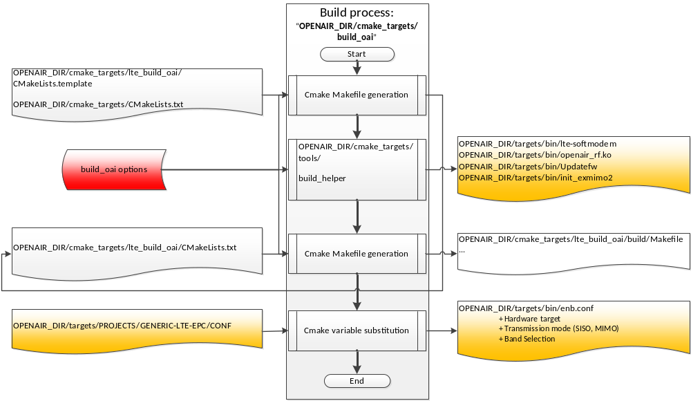
Figure 3 OAI eNB build process and configuration
Inputs files and parameters are on the left part of the figure, the build process is in the center part and output configuration files are on the right side of the figure.
eNB configuration file contents are detailed in Appendix A.
Configuration files have to be filled prior to compilation.

eNB build and Run
open a shell, and run
- user@host:~/openair4G/trunk/cmake_targets$ ./build_oai –h
Different targets are available as follows:

EXMIMO Target
To build:
- user@host:~/openair4G/trunk/cmake_targets$ ./build_oai -g –eNB –X
To run:
- user@host:~/openair4G/trunk/targets/bin$ ./init_exmimo2
- user@host:~/openair4G/trunk/targets/bin$ sudo –E ./lte-softmodem.Rel10 –O .. ../PROJECTS/GENERIC-LTE-EPC/CONF/enb.band7.tm1.exmimo2.conf –S –d
for Help
- user@host:~/openair4G/trunk/targets/bin$ sudo –E ./lte-softmodem.Rel10 –h

USRP Target
To build:
- user@host:~/openair4G/trunk/cmake_targets$ ./build_oai -g –eNB –X –w USRP
To run :
- user@host:~/openair4G/trunk/targets/bin$ sudo –E ./lte-softmodem.Rel10 –O .. ../PROJECTS/GENERIC-LTE-EPC/CONF/enb.band7.tm1.usrp210.conf –S –d
for Help:
- user@host:~/openair4G/trunk/targets/bin$ sudo –E ./lte-softmodem.Rel10 –h

UE build and Run

EXMIMO
To build:
- user@host:~/openair4G/trunk/cmake_targets$ ./build_oai -g –UE –X
To run:
- user@host:~/openair4G/trunk/targets/bin$ ./init_exmimo2
- user@host:~/openair4G/trunk/targets/bin$ sudo –E ./lte-softmodem.Rel10 –U -C 2680000000 -r25 --ue-scan-carrier -g7 -d

USRP
To build:
- user@host:~/openair4G/trunk/cmake_targets$ ./build_oai -g –UE –X –w USRP
To run:
- user@host:~/openair4G/trunk/targets/bin$ sudo –E ./lte-softmodem.Rel10 –U -C 2680000000 -r25 --ue-scan-carrier -g7 -d

OAISIM build and Run
To build:
- user@host:~/openair4G/trunk/cmake_targets$ ./build_oai -g --oaisim
to Run:
- With local S1: user@host:~/openair4G/trunk/targets/bin$ sudo –E ./oaisim.Rel10 –O ../PROJECTS/GENERIC-LTE-EPC/CONF/enb.band7.generic.oaisim.local_mme.conf
- Without S1: user@host:~/openair4G/trunk/targets/bin$ sudo –E ./oaisim.Rel10 –O ../ ../PROJECTS/GENERIC-LTE-EPC/CONF/enb.band7.generic.oaisim.local_no_mme.conf

Test OAI
user@host:~/openair4G/trunk/cmake_targets$ ./build_oai -s

eNB Monitoring tools
OAI provides monitoring tools such as network protocol analyzers, loggers, performance profilers, timing analyzers and command line interfaces for performing the intended measurements and monitoring the network. Specifically, the supported monitoring tools are:

- OAI Soft Scope and Status can be read remotely.
- Wireshark / PCAP Interface:
  - L2/L3 and S1 interface.
  - Localhost or remote host access.
  - Example can be found at :
- OAI Logger and dissector (called itti_analyzer):
  - Remote log file retrieval
- OpenAirInterface performance profiler: for processing time measurement.
- OpenAirInterface timing analyzer: build the VCD
  - Convert the ascii variables and function calls output to vcd format (value change data) allowing to view the temporal function and variable changes in a vcd viewer, such as gtkwave.
- OAI message sequence chart (MSC) : http://www.mcternan.me.uk/mscgen/.
- CLI interface.

The figures below depict the provided monitoring tools and their functionality via typical measurement and packet capture examples. In addition, MSC examples are illustrated.

OAI Soft Scope provides plots for received signal power, channel impulse response, channel frequency response, channel frequency response, LLRs, throughput and I/Q components (e.g., 4-QAM constellation). This tool offers a complete overview of the PHY layer characteristics, an example is shown in Figure 4.

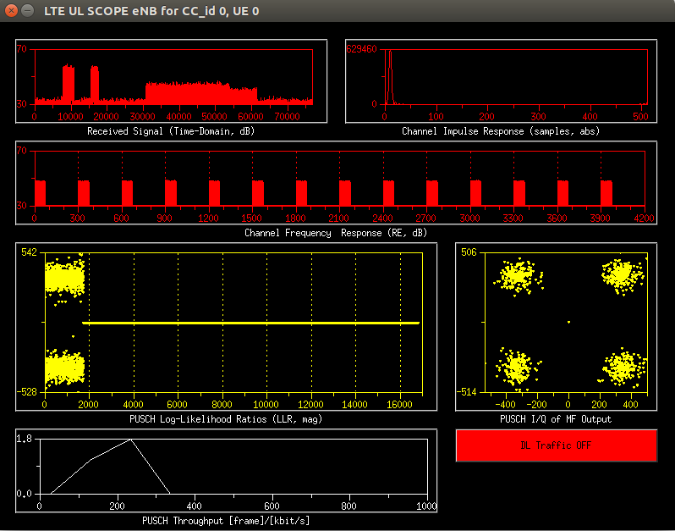
Figure 4: OAI Soft Scope: Received Signal, Channel Impulse Response, LLRs, I/Q and Throughput plots
Wireshark is a powerful tool widely used for capturing packets, offering integrated sorting and filtering options. In addition to layer 3 protocol dissection, OpenAirInterface implements the Wireshark interface for the layer 2 protocol dissection for PDCP, RLC, and MAC layer. In Figure 5, an example illustrates RRCConnectionReconfiguration message capture using Wireshark.
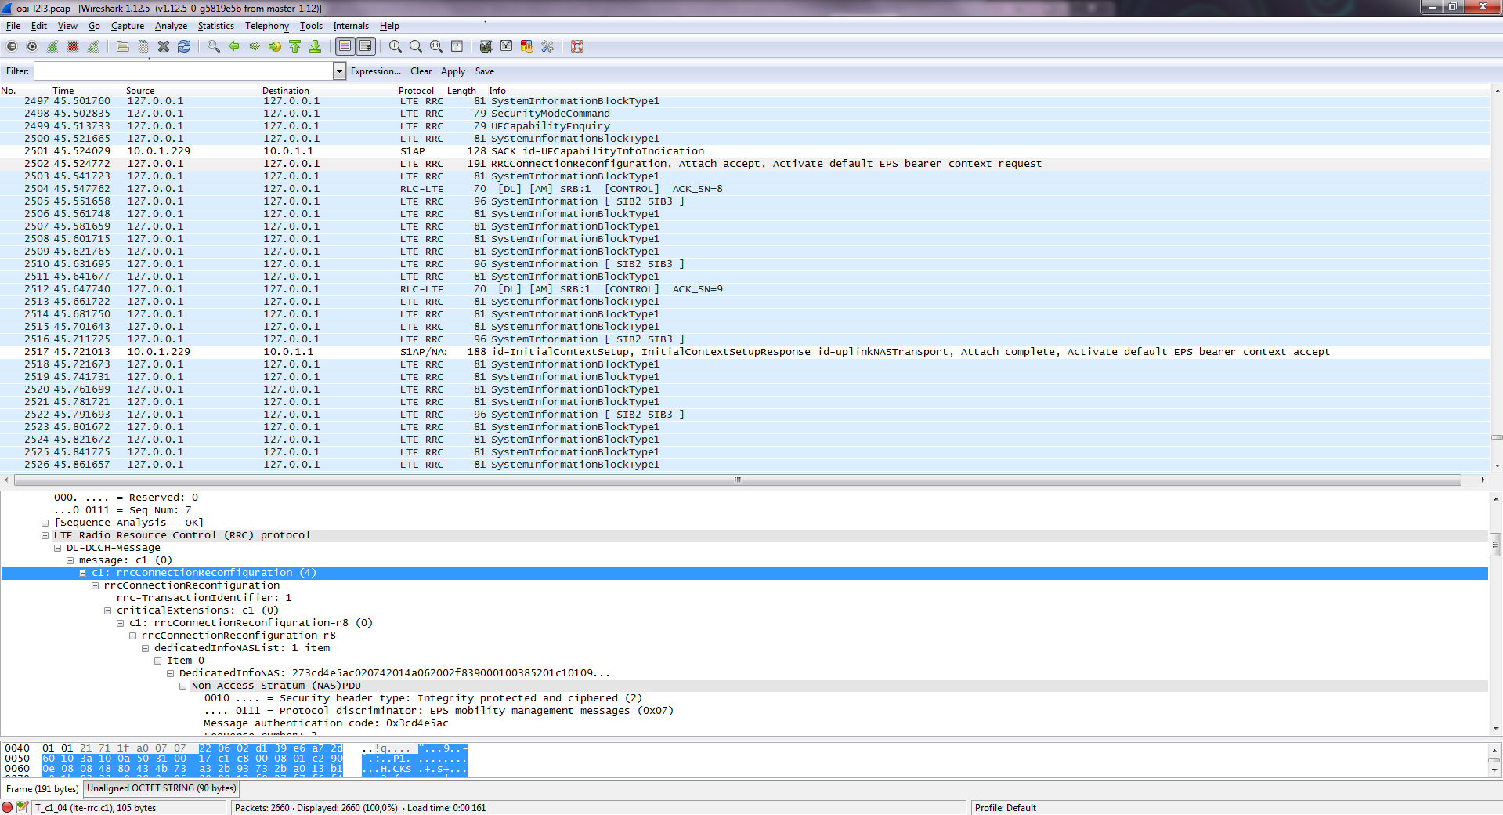
Figure 5: Wireshark: RRCConnectionReconfiguration message capture

The itti_analyzer tool can be used to analyze the exchanges between RRC<->S1AP, RRC<->PDCP, PDCP<->S1. In addition to the protocol information, the itti_analyzer analyses all the messages exchanged between different protocols. It allows message filtering on per time, channel (CCCH, DCCH, DTCH), sender, and receiver basis allowing to monitor and follow the protocol functionalities. Figure 6 depicts an example for RRCConnectionReconfiguration message capture using the itti_analyzer.

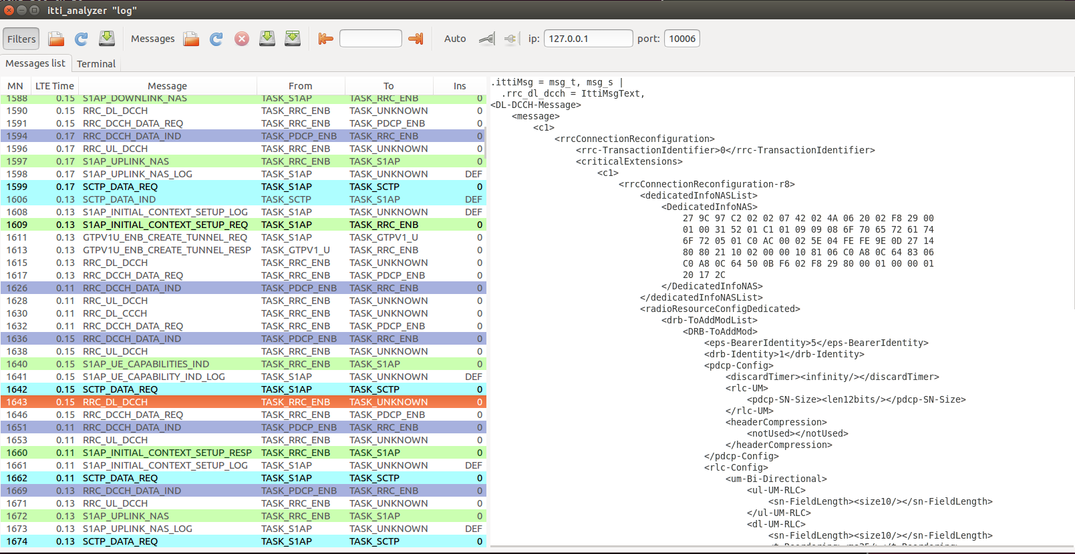
Figure 6: ITTI analyser: RRCConnectionReconfiguration message capture

OAI provides a logger exploited for code testing, debugging, checking protocols functionality and storing messages information. The OAI logger can be configured in the eNB configuration file. The logs have the following format:
[COMP][LOG LEVEL][FUNC][ID][FRAME NUM][CONTENT] as described below:
- COMP: represents the log component and can be S1AP, GTP, RRC, PDCP, RLC, MAC, PHY.
- LOG LEVEL: represents the level and verbosity of the logs, and can have the following values: Emerge, Alert, Critic, Error, War, Notice, Info, Debug, Trace.
- FUNC: represents the name of the function inside which the log is called (This is an optional block).
- ID: represents the eNB Identifier.
- FRAME NUM: represents the frame counter.
- CONTENT: shows the content of the log message.

Figure 7 shows an instance of messages exchange that is stored in OAI logger. This information is used for further study by the experimenters and code analysis/debugging for the developers.
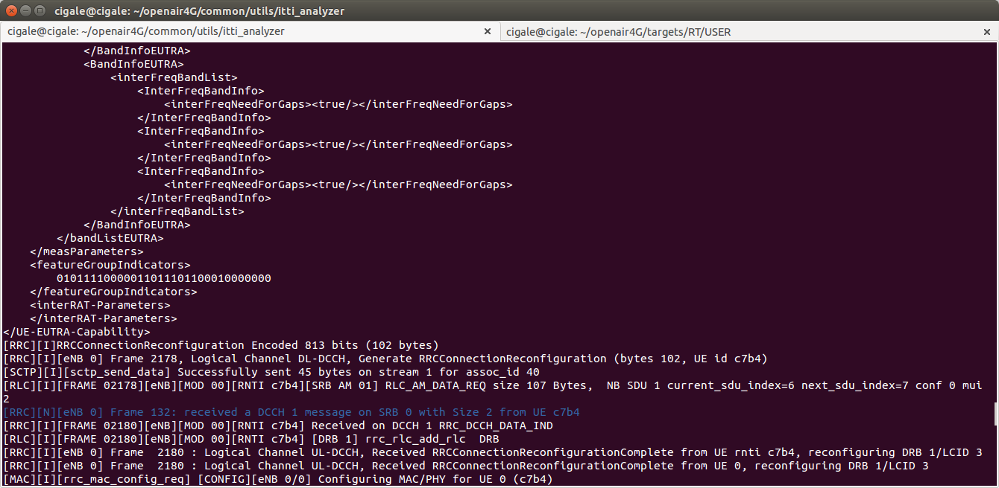
Figure 7: OAI logger: RRCConnectionReconfigurationComplete reception

OAI offers online statistics for the status of the network (e.g., successful transmissions, errors per HARQ per round, average throughput etc.). Figure 8 depicts the ULSCH/DLSCH errors per HARQ process (8 in LTE FDD) per round (4 is maximum). The provided statistics can be used in experimental measurements for performance evaluation of the system.

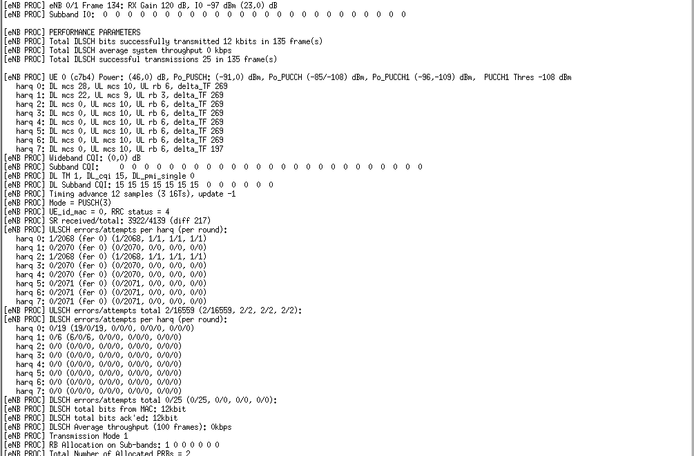
Figure 8: OAI online statistics
The timing analyser is a helpful tool that tracks the execution time of each function working as a common profiler for performance improvement. The tool is exploited for code optimization, bottleneck detection, and processing time measurements. In Figure 9, a detailed track of the execution time of the selected functions is depicted.

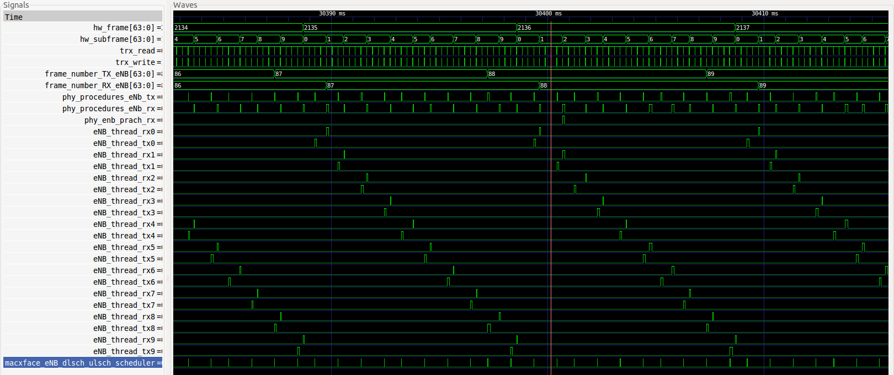
Figure 9: Timing analyser
OAI uses MSC for representing network entities/interfaces (i.e., eNB, UE, MME, HSS, S6A etc.) and their interactions in a diagrammatic form. Arrows direction defines the sender/receiver and explanatory comments are included. The examples in Figure 10 and Figure 11 show an instance of E_UTRAN and EPC messages exchange, respectively.

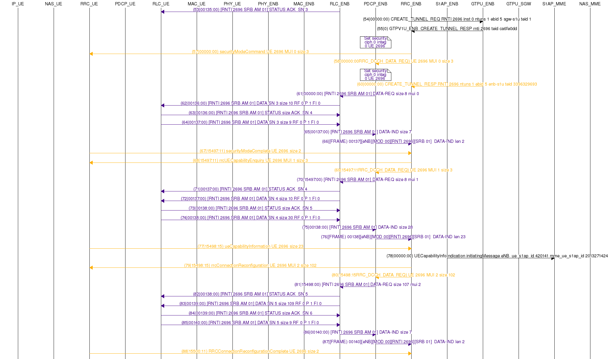
Figure 10: MSC for E_UTRAN messages (e.g., UE Capability Enquiry, UE Capability Information, RRC Connection Reconfiguration, RRC Connection Reconfiguration Complete etc.)

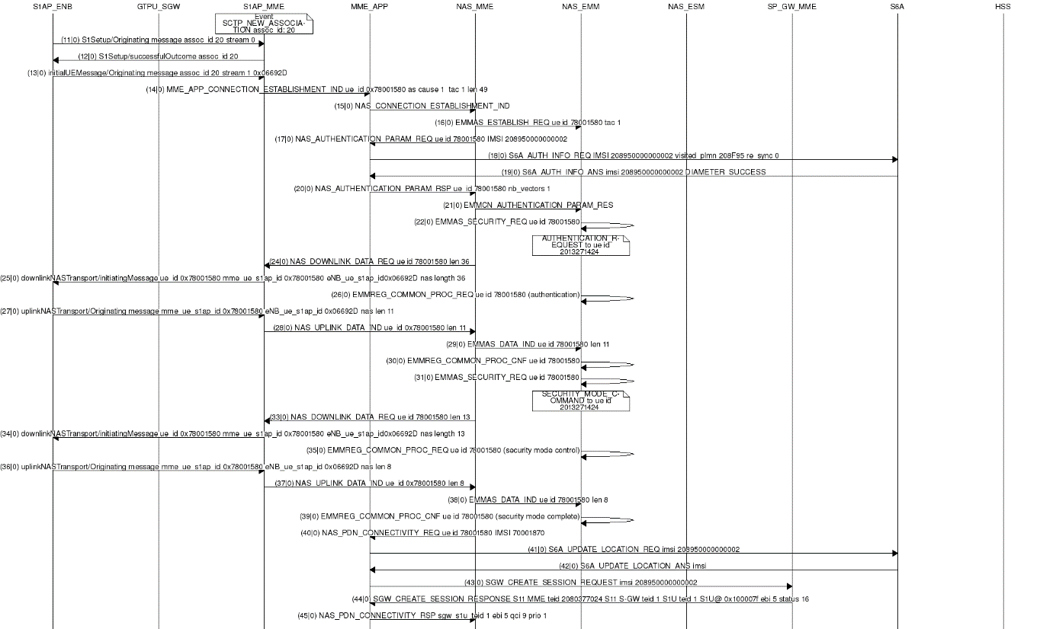
Figure 11: MSC for EPC messages (e.g., S1AP Initial UE Message [Attach Request + PDN Connectivity Request], Update location Request etc.)

References
- Nikaein, Navid; Knopp, Raymond; Kaltenberger, Florian; Gauthier, Lionel; Bonnet, Christian; Nussbaum, Dominique; Ghaddab, Riadh, “OpenAirInterface: an open LTE network in a PC”, url: http://www.eurecom.fr/publication/4371
- Nikaein, Navid; Knopp, Raymond; Gauthier, Lionel; Schiller, Eryk; Braun, Torsten; Pichon, Dominique; Bonnet, Christian; Kaltenberger, Florian; Nussbaum, Dominique , “Closer to cloud-RAN: RAN as a service”, url: http://www.eurecom.fr/publication/4632
- OpenAirInterface Twiki, URL: https://twiki.eurecom.fr/twiki/bin/view/OpenAirInterface
- OpenAirInterface SVN repository: https://svn.eurecom.fr/openair4G/trunk/

  - eNB configuration
The eNB configuration parameters are presented here. All the parameters are divided in the following 6 main sections:
    - Main section
Parameter | Type
real_time | String | Real time compilation
eNB_ID | Integer | eNB identifier
cell_type | String | Type of the cell
eNB_name | String | Name of eNB
tracking_area_code | String | Tracking area code (TAC)
mobile_country_code | String | Mobile country code (MCC)
mobile_network_code | String | Mobile network code (MNC)
Table 1 eNB configuration main section
    - Physical parameters section
Parameter | Type
frame_type | String | Type of the frame (e.g., FDD,TDD)
tdd_config | Integer
timer_status_prohibit | Integer
tdd_config_s | Integer
prefix_type | String | Cyclic prefix
eutra_band | Integer | EUTRA band (e.g., 7, 13)
downlink_frequency | Double | Downlink frequency
uplink_frequency_offset | Integer | Uplink frequency offset
Nid_cell | Integer | Physical layer cell identity
N_RB_DL | Integer | Number of resource blocks (RBs) in Downlink
Nid_cell_mbsfn | Integer
nb_antennas_tx | Integer | Number of Tx antennae
nb_antennas_rx | Integer | Number of Rx antennae
tx_gain | Integer | Tx gain
rx_gain | Integer | Rx gain
prach_root | Integer
prach_config_index | Integer | Parameter that defines exactly when UE should send RACH in frequency/time grids (Details TS36.211 Table 5.7.1-2)
prach_high_speed | String
prach_zero_correlation | Integer | The zero correlation zone is used to guarantee orthogonality of generated sequences. The value depends on particular condition in the cell
prach_freq_offset | Integer | With this information, cell informs UE and other neighbor cells know about which PRB is available for RACH access
pucch_delta_shift | Integer
pucch_nRB_CQI | Integer | Number of resource blocks for channel quality indicator (CQI) periodic reporting
pucch_nCS_AN | Integer | Cyclic shift used for PUCCH1
pucch_n1_AN | Integer | PUCCH to be used for HARQ (Rel 10)
pdsch_referenceSignalPower | Integer | This defines the energy per resource element for the reference signal using a range from -60 to 50 dBm
pdsch_p_b | Integer | It is used to calculate the power difference between PDSCH and Reference Signal. Value is from 0 to 3
pusch_n_SB | Integer | Number of subbands (range 1 to 4)
pusch_enable64QAM | String | 64QAM (enable/disable)
pusch_hoppingMode | String | Hopping mode can be inter-subframe, intra or inter-subframe
pusch_hoppingOffset | Integer | Offset values range from 1 to 98
pusch_groupHoppingEnabled | String | Group hopping (enable/disable)
pusch_groupAssignment | Integer | Parameter that gives sequence shift pattern for group hopping (0 to 29)
pusch_sequenceHoppingEnabled | String | Sequence hopping (enable/disable)
pusch_nDMRS1 | Integer
phich_duration | String
phich_resource | String
srs_enable | String
pusch_p0_Nominal | Integer | Impacts the calculation of PUSCH transmit power and applicable to non-persistent scheduling only (-126 to 24 dBm)
pusch_alpha | String | Impacts the calculation of PUSCH transmit power and also scales the contribution of path loss. Possible values are 0, 0.4, 0.5, 0.6, 0.7, 0.8, 0.9 and 1
pucch_p0_Nominal | Integer | Impacts the calculation of PUSCH transmit power and applicable to non-persistent scheduling only (-126 to 24 dBm)
msg3_delta_Preamble | Integer | Impacts the transmit power of PUSCH when responding to random access response grant (-1 to 6dB)
pucch_deltaF_Format1 | String | Uplink power control parameter
pucch_deltaF_Format1b | String | Idem above
pucch_deltaF_Format2 | String | Idem above
pucch_deltaF_Format2a | String | Idem above
pucch_deltaF_Format2b | String | Idem above
rach_numberOfRA_Preambles | Integer | Total number of random access preambles available for contention based random access. Since there are maximum 64 preambles sequences available, others could be reserved by eNB for Non-Contention based random access. Range of this parameter is 4 to 64
rach_preamblesGroupAConfig | String
rach_powerRampingStep | Integer | Power ramping step size with possible values of 0, 2, 4 or 6 dB
rach_preambleInitialReceivedTargetPower | Integer | Preamble initial received target power with values from -120 dBm to -90 dBm with step size of 2 dBm
rach_preambleTransMax | Integer | Maximum number of preambles transmissions. Possible values are 3, 4, 5, 6, 7, 8, 10 ,20, 50, 100, 200
rach_raResponseWindowSize | Integer | Duration of RA response window. RA response window size is in unit of subframes (2, 3, 4, 5, 6, 7, 8, or 10 subframes)
rach_macContentionResolutionTimer | Integer | Mac contention resolution timer in unit of subframes
rach_maxHARQ_Msg3Tx | Integer | Maximum number of HARQ retransmissions for message 3 of RACH process (contention-based Random access) with possible values from 1 to 8 in step of 1
pcch_default_PagingCycle | Integer | The default DRX cycle in idle mode in unit of radio frames
pcch_nB | String | Parameter used in finding the actual paging frames and paging occasions in RRC idle mode
bcch_modificationPeriodCoeff | Integer | The value (2,4,6,8) of this parameter is multiplied with default DRX cycle (e.g., 320ms, 640ms) to generate the BCCH modification period
ue_TimersAndConstants_t300 | Integer | Starts at the RRC Connection REQ transmit
ue_TimersAndConstants_t301 | Integer | Starts at the RRC Connection Re-establishment REQUEST
ue_TimersAndConstants_t310 | Integer | Starts when UE detects PHY layer related problems (when it receives N310 consecutive out-of-sync INDs from lower layers)
ue_TimersAndConstants_t311 | Integer | Starts while initiating Connection Re-establishment procedure
Table 2 eNB configuration subsection SRB1 parameters
    - SRB1 parameters section
Parameter | Type
timer_poll_retransmit | Integer | Timer for poll retransmission
timer_reordering | Integer | RLC AM reordering timer
timer_status_prohibit | Integer
poll_pdu | Integer
poll_byte | Integer
max_retx_threshold | Integer
Table 3 eNB configuration subsection SRB1 parameters
    - MME parameters section
Parameter | Type
ipv4 | String | IPv4 address
ipv6 | String | IPv6 address
active | String | Activation (yes/no)
preference | String | IPv4 or IPv6
Table 4 eNB configuration subsection MME parameters
    - Network interfaces section
Parameter | Type
ENB_INTERFACE_NAME_FOR_S1_MME | String | Interface name for S1-MME (e.g., eth1)
ENB_IPV4_ADDRESS_FOR_S1_MME | String | eNB IPv4 subnet for S1-MME
ENB_INTERFACE_NAME_FOR_S1U | String | Interface name for S1-U (e.g., eth1)
ENB_IPV4_ADDRESS_FOR_S1U | String | eNB IPv4 subnet for S1-U
ENB_PORT_FOR_S1U | String | eNB port for S1-U
Table 5 eNB configuration subsection Network interfaces
    - Log config
Parameter | Type
global_log_level | String | Global logger level (e.g., emerg, alert, crit, error, warn, notice, info, debug, trace)
global_log_verbosity | String | Global logger verbosity level (e.g., none, low, medium, high, full)
hw_log_level | String | HW logger level (e.g., emerg, alert, crit, error, warn, notice, info, debug, trace)
hw_log_verbosity | String | HW logger verbosity level (e.g., none, low, medium, high, full)
phy_log_level | String | PHY logger level (e.g., emerg, alert, crit, error, warn, notice, info, debug, trace)
phy_log_verbosity | String | PHY logger verbosity level (e.g., none, low, medium, high, full)
mac_log_level | String | MAC logger level (e.g., emerg, alert, crit, error, warn, notice, info, debug, trace)
mac_log_verbosity | String | MAC logger verbosity level (e.g., none, low, medium, high, full)
rlc_log_level | String | RLC logger level (e.g., emerg, alert, crit, error, warn, notice, info, debug, trace)
rlc_log_verbosity | String | RLC logger verbosity level (e.g., none, low, medium, high, full)
pdcp_log_level | String | PDCP logger level (e.g., emerg, alert, crit, error, warn, notice, info, debug, trace)
pdcp_log_verbosity | String | PDCP logger verbosity level (e.g., none, low, medium, high, full)
rrc_log_level | String | RRC logger level (e.g., emerg, alert, crit, error, warn, notice, info, debug, trace)
rrc_log_verbosity | String | RRC logger verbosity level (e.g., none, low, medium, high, full)
gtpu_log_level | String | GTPU logger level (e.g., emerg, alert, crit, error, warn, notice, info, debug, trace)
gtpu_log_verbosity | String | GTPU logger verbosity level (e.g., none, low, medium, high, full)
udp_log_level | String | UDP logger level (e.g., emerg, alert, crit, error, warn, notice, info, debug, trace)
udp_log_verbosity | String | UDP logger verbosity level (e.g., none, low, medium, high, full)
osa_log_level | String | OSA logger level (e.g., emerg, alert, crit, error, warn, notice, info, debug, trace)
osa_log_verbosity | String | OSA logger verbosity level (e.g., none, low, medium, high, full)
Table 6 eNB configuration subsection Log config

An example of eNB config file is located at: https://svn.eurecom.fr/openair4G/trunk/targets/PROJECTS/GENERIC-LTE-EPC/CONF/enb.band7.exmimo2.conf
The type and the declaration of the parameters as variables can be found in the corresponding C file: https://svn.eurecom.fr/openair4G/trunk/openair2/ENB_APP/enb_config.c
Example of the pcap file can be found at: https://twiki.eurecom.fr/twiki/pub/OpenAirInterface/IttiAnalyzer/oai_l2l3.pcap. To view the messages, you need to enable UDP heuristics in the protocol preferences of Wireshark.

